**Game Programming**

**Assignment 3**

**Score: 7/10**

**Game programming:**

Sir Omer Chattha

**Group members:**

Mubashar Azad **2369**

Muhammad Usman **2544**

Touqeer Ahmed **2328**

Zamama Zaman **2128**

Task 1: Take the elements from GCD / GDD and identify the main modules of your game projects. Divide the modules into sub activities / tasks and construct the full WBS for your project. Also create a WBS dictionary explaining each task separately.

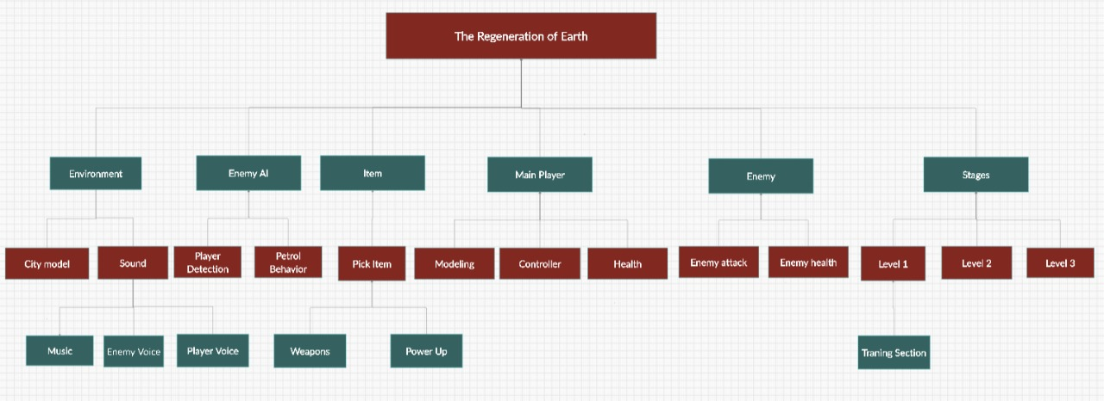

Task:2 Take the output of WBS (tasks/activities) and use it as an input to create a project Gantt Chart for your game projects.

|  |  |  |  |  |  |  |  |  |  |  |  |  |
| --- | --- | --- | --- | --- | --- | --- | --- | --- | --- | --- | --- | --- |
| Tasks | Week 1 | Week 2 | Week 3 | Week 4 | Week 5 | Week 6 | Week 7 | Week 8 | Week 9 | Week 10 | Week 11 | Week 12 |
| Documentation |  |  |  |  |  |  |  |  |  |  |  |  |
| Environment |  |  |  |  |  |  |  |  |  |  |  |  |
| Enemy AI |  |  |  |  |  |  |  |  |  |  |  |  |
| Item |  |  |  |  |  |  |  |  |  |  |  |  |
| Main Player |  |  |  |  |  |  |  |  |  |  |  |  |
| Enemy |  |  |  |  |  |  |  |  |  |  |  |  |
| Stages |  |  |  |  |  |  |  |  |  |  |  |  |